Geosemantic Maps: Dynamic and Definition in an Academic Environment

Mapping Meaning across Mills College Modernity

Iman Habib

Mills College
11 October 2011

Abstract
It would be interesting to connect the programs of insight which correspond to the modern day academic space. Specifically, at Mills College, how frequently and quickly does “discourse” and “rhetoric” define a popular imagination? There are many ways in which academic spaces across geographic lines negotiate and connect with certain domains or themes which shape our language and system of knowledge. If there are assumed similarities, the differences cannot go unnoticed. In this study, we can attempt to isolate the popular academic environment and pick out the insight through broad domain of Geographic Linguistics. This domain is significant because it represents the mode by which we are able to obtain data – the meaning of the linguistic versus the structure. Semantic Mapping is adaptation of concept definition mapping that builds on students’ and teachers’ prior knowledge or schema. . .
I think we need to try to get a little more concrete. One has be careful that one's own rhetoric doesn't soar too far above the ground at the start….

Introduction
In this project I will use GIS to study the geography of academic semantics across disciplines at Mills College. The spatial distribution of X is interesting because it shows how and ….
Is there enough "space" within Mills to see variation? Micro-mapping is hard in principle. Variations can be small and so you need enormous samples to get enough statistical power to separate out signal from noise.
I CAN imagine that one might be able to interview a large number of people who hail from different locations and ask them about some things that we know vary in terms of language use (a little linguistics research would be in order to find some –the old classic is "pop" vs. "soda"). I don't know if there is enough variation at Mills to see such things though.
Related projects might be to see if there were language differences in, say, letters to the editor in newspapers across the country (on adjectives used in connection with something, for example).
Or language in Craigslist ads?
In any case, be sensitive to the fact that there has to be some variation over the space being examined if we are to see anything interesting.

Research Question or Purpose of Project
How frequently and effectively can a specific location

Maps and Analyses
Ethnosemantic Interview Method
Data Sources
Geographic Linguistic map 1890
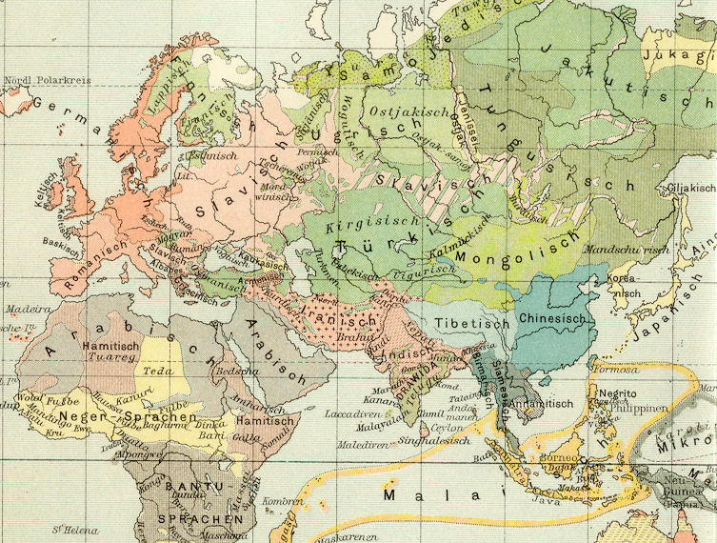

Linguistic Map of Switzerland
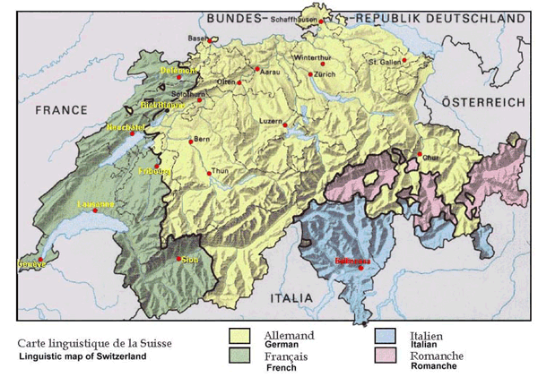
Cool Map: Second Life teleporting?
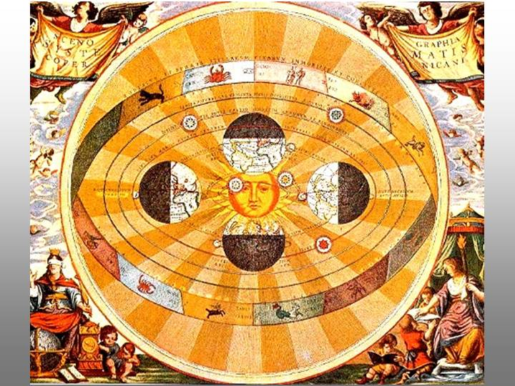
Ancient Mesopotamian land ownership map
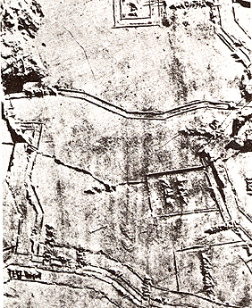
Knowledge growth map
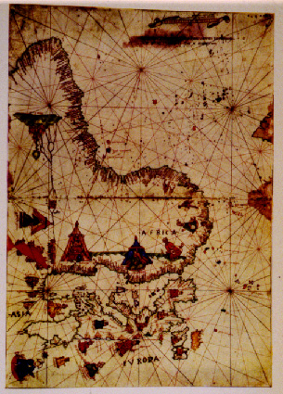

Star Map: the tribe's social and religious organizations that reflect and interact with those heavenly forces
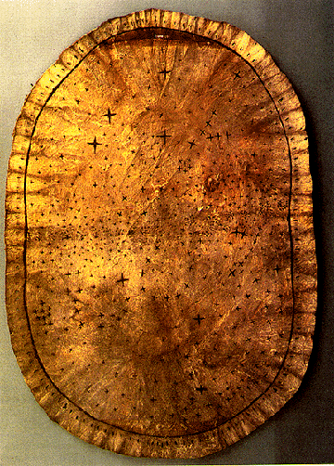

Exemplars
Do you want to do a project that is just like something? Or just like something but different.

Time Line

TODAY: write some commentary about the above maps – what about them strikes your interest?
18 October
25 October
1 November
8 November
15 November
22 November
29 November Presentations
6 December Presentations

References
http://krygier.owu.edu/krygier_html/geog_222/geog_222_lo/geog_222_lo05.html
http://www.davidrumsey.com/
http://www.wagsoft.com/Papers/Thesis/06Interpersonal.pdf
Properly formatted list of sources.

