Navigating Oakland:

Perceptions and Individual Experiences of Oakland, California

A Proposal

Karin Dahl

Mills College
11 October 2011

Abstract
In this project, I will collect hand drawn maps of Oakland from residents showing their personal experiences of the city. I will analyze the contents of the maps drawn and digitize the results in ArcGIS. The information from the hand drawn maps may show variables such as the frequency in appearance of particular landmarks, average perceived distance between landmarks, and routes traveled. As a side, I am also interested in the aesthetic variations of the drawings.

Introduction
In this project I will use GIS to study the perceptual geography of Oakland. The differences in spatial distribution of landmarks, routes traveled and perceived distances between landmarks, will give an overview of individual experiences of navigating Oakland.

Research Question or Purpose of Project
How do people represent their individual experiences of Oakland via a hand drawn map? What are the commonalities in placement of landmarks –which landmarks are included or excluded? And what are the most common routes taken?
*I might also consider asking people from different points in Oakland for directions to a particular landmark and map the variations. Example: going to 5 different places in Oakland and asking “Could you give me directions to Lake Merritt?” Though this could be its own study, I think it would be a nice addition to the hand drawn maps of Oakland

Maps and Analyses
- Landmarks included – what are the landmarks (library, intersection, stores, etc) most frequently included in the maps
- Average distance between landmarks – are people’s relative perceptions of distances between two landmarks different. This might be difficult to analyze but if I can figure out a way it would be really neat
- Boundaries of Oakland – what do people include as Oakland? Where does it start and end?
- Creating transparencies of all maps created and layering them over one another – might look like a big crazy blob but could also make a neat art piece.
- Potential for creating database of maps of “individual experiences of Oakland” that can be interactively navigated through a website or compiled in some sort of book format (zine?), or all/both thinking of how this could be useful/interesting to the participants?

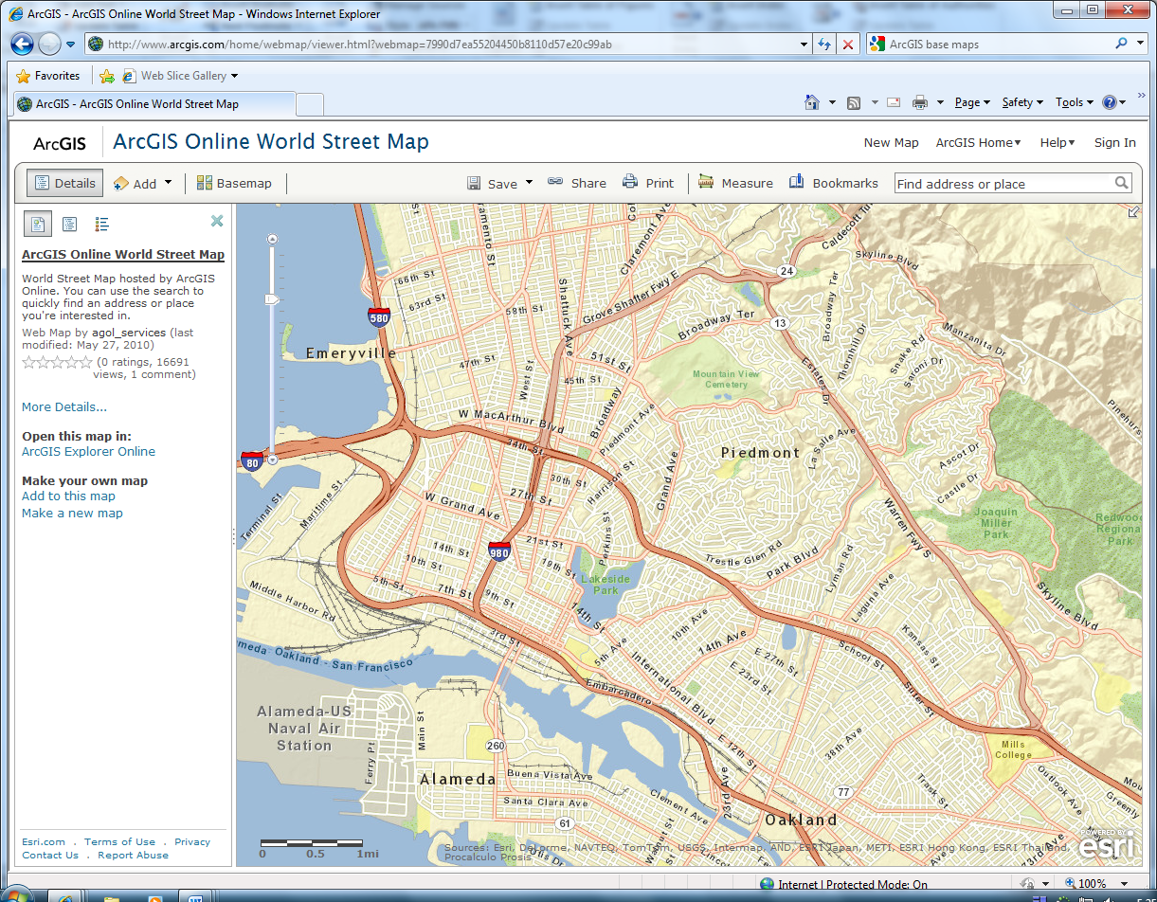

http://www.arcgis.com/home/webmap/viewer.html?webmap=7990d7ea55204450b8110d57e20c99ab

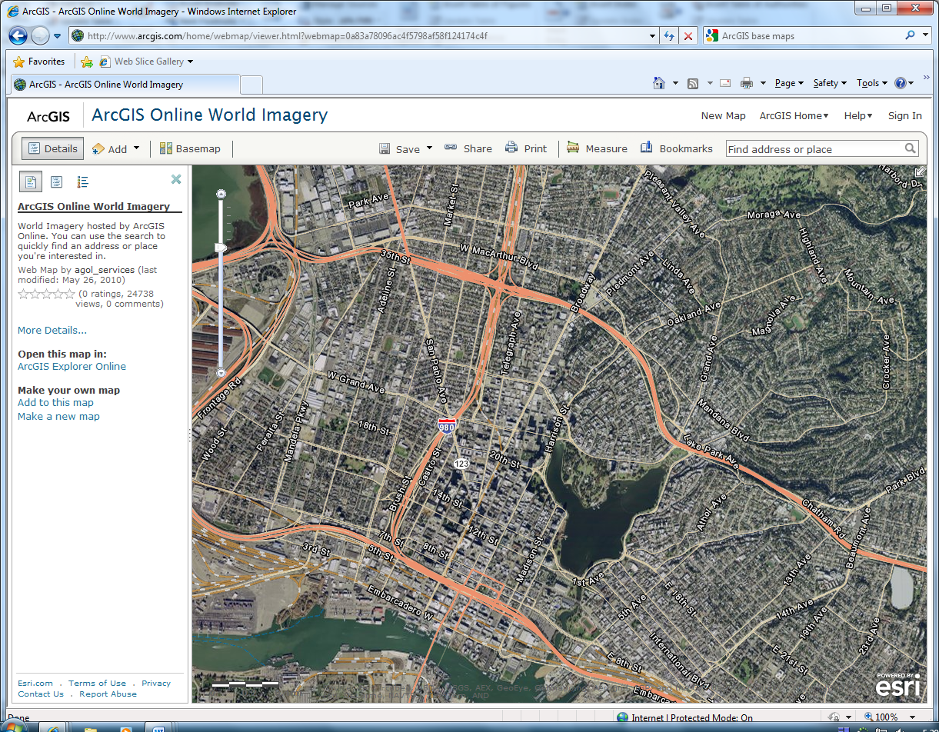

http://www.arcgis.com/home/webmap/viewer.html?webmap=0a83a78096ac4f5798af58f124174c4f

Data Sources
Base Maps: I will make use of the base maps provided in ArcGIS. The primary base map will be of the Oakland area, street map
Data Collection: To begin, I will make use of the people I know and their friends to do an informal survey of hand drawn maps of Oakland. Depending on the outcome of this preliminary data collection I will continue to gather as many hand drawn maps as possible. I will use social media (Facebook) and word of mouth to gather participants. All participants will receive a blank 8.5x11in piece of paper (or with one existing landmark on it (Lake Merritt?), depending on results of pilot study)

Exemplars/Inspiration
Mapping Oakland: http://www.mappingoakland.com/
The Mapping Oakland project was carried out by UC Berkeley Landscape Architecture student Robert Lemon. He administered an online survey asking questions about the use of public space and the different perceived boundaries of Oakland neighborhoods.
The Hand Drawn Maps Association: http://www.handmaps.org/index.php
The Hand Drawn Maps Association is both a physical and digital archive of hand drawn maps submitted by anyone willing to contribute. The maps range from directions from one point to another to

Time Line
16 October – At least 5 preliminary hand drawn maps collected
18 October – Finalized proposal
25 October
1 November
8 November
15 November
22 November
29 November Presentations
6 December Presentations

References
Lynch, Kevin. The Image of the City. Cambridge: M.I.T. Press, 1960.

