Mapping Tweets: Various Occupations across the United States

A Proposal

Sophanarot Sam

Mills College
11 October 2011

Abstract
In this project I will map tweets that are related to the recent trend of the various occupations that has occurred across the United States. I will collect tweets from the Twitter website, which includes when the content was tweeted/re-tweeted, who (the username) tweeted the content, and where the tweeter is from. With this data, I will create an excel spread sheet that will be imported into Geographic Information System. The map will display tweets from all across the U.S. that contains the content “#Occupy Wall Street” and “#Occupy […].”

Introduction
In this project I will use GIS to develop a geographical map of tweets about the recent phenomenon of the occupation of various places that was triggered by the Occupation of Wall Street. The spatial distribution of tweets related to the occupation is interesting because it reveals a visual representation of an ongoing social movement in the United States.

Research Question or Purpose of Project
What is the geography of this recent social movement of occupations?

Maps and Analyses
I will use the map of the United States.
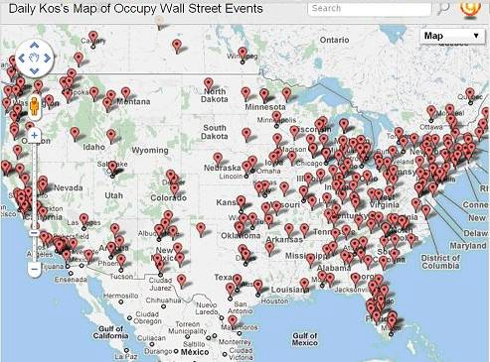

Data Sources
I will retrieve a bas map from GIS. I will retrieve data from Twitter by collecting tweets through using the Archivist, which is a program that retrieves data from Twitter and archives it. Census Data.
URLS:
- http://archivist.visitmix.com/
- http://wonkette.com/454489/hundreds-of-occupations-nationwide-find-one-close-to-you
- http://twitter.com/
- http://motherjones.com/politics/2011/10/occupy-wall-street-protest-map
- http://www.census.gov/

Exemplars
I would like to do a project that is different from current mappings of tweets related to the occupations in the United States.

Time Line

Things to do: Kalisi

Retrieve data through the archivist

Figure out if geographical information is included in tweets

Sophanarot

Search for maps

Help Kalisi with formatting Excel spreadsheet
18 October: Have a set of base maps
25 October: Figure out if geographical information is included in tweets
1 November: Catch up on work
8 November: End of collections of data from twitter
15 November: Begin constructing maps
22 November: Continue constructing maps
29 November: Finalize Presentation
6 December Presentations by Kalisi and Sophanarot

References
Aidlin, Tim and Karsten Januszewski. 2011. The Archivist: Save and Analyze Tweets. Retrieved October 11, 2011. (http://archivist.visitmix.com/)
Dorsey, Jack. 2006. Twitter. Retrieved October 11, 2011. (http://twitter.com/)

Jr., Wonkette. 2011. “Hundreds of Occupations Nationwide: Find One Close to You!” Retrieved October 11, 2011. (http://wonkette.com/454489/hundreds-of-occupations-nationwide-find-one-close-to-you)

The Mother Jones News Team. 2011. “Map: Occupy Wall Street Spreads Worldwide, Arrest on the Rise.” Retrieved October 11, 2011. (http://motherjones.com/politics/2011/10/occupy-wall-street-protest-map)

